CO3 - Activity -5 - Normality Detection using Q-Q Plots

Department | AI&DS
Course Code / Course Name | DSA0602/ Data Handling and Visualization
Activity | Normality Detection using Q-Q Plots
Name | Addula Yaswanth
Register Number | 192324179

Each chart is a normal Q-Q plot made in R (stat_qq and stat_qq_line; red line = perfect normal fit). Part A (16 marks): for every chart decide whether the data are normal and name the shape from this list: Normal, Right-skewed, Left-skewed, Heavy-tailed, Light-tailed, Bimodal, Normal with outlier(s); then cite the evidence you see.
1.
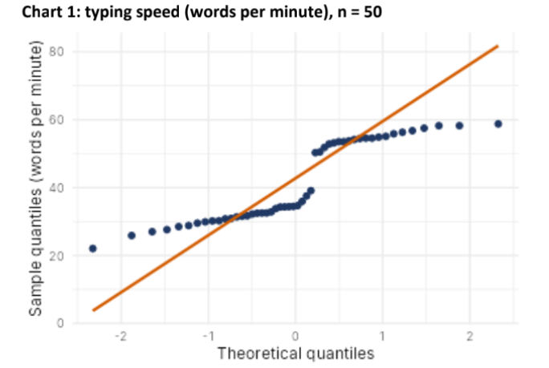
Normal? (Yes / No) | No
Shape (from the list) | S- Shaped
Evidence in the plot | Points form a clear S-shaped curve and deviate from the reference line.

2.
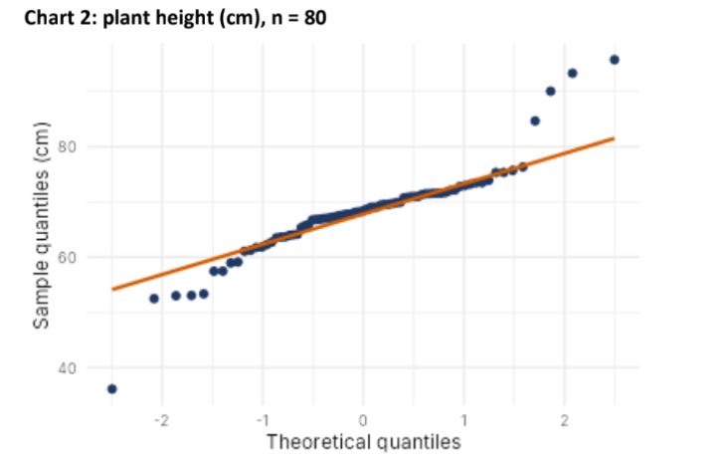
Normal? (Yes / No) | No
Shape (from the list) | Right-skewed
Evidence in the plot | The upper-tail points rise well above the reference line.

3.
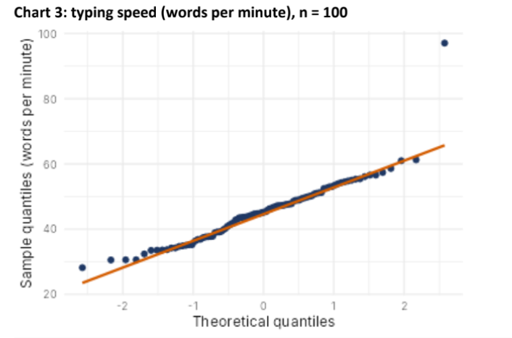

Normal? (Yes / No) | No
Shape (from the list) | Right-skewed / outlier
Evidence in the plot | Most points follow the line, but one extreme upper point lies far above it.

4.
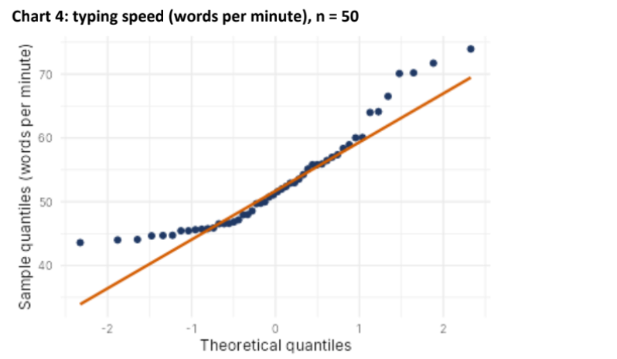

Normal? (Yes / No) | No
Shape (from the list) | Right-skewed
Evidence in the plot | Points deviate from the line in the tails, especially the upper tail.

Part B (4 marks)
B1. Chart 4 departs from normality. Name the departure and state the remedy you would try before using mean-and-SD methods (for example log transform, square, split the data, robust methods).
- Departure: Right-skewness.
- Remedy: Try a log transformation, then inspect the Q-Q plot again. If the departure remains, consider a robust method.

B2. Fill the blanks to draw a Q-Q plot with its reference line for a data frame df with a column value: ggplot(df, aes(sample = value)) + ________ + ________
ggplot(df, aes(sample = value)) + stat_qq() + stat_qq_line()

